REAL TIME SPORTS ANALYSIS AND PREDICTION

**Dr. P. Nagaraj**  
CSE-Dept(Assistant professor)  
Kalsalingam Academy of Research and educationVirudh nagar,India  
nagaraj.p@klu.ac.in

**G Charan Kumar Naidu**  
*Computer science and engineering*  
*Kalasalingam academy of research and education*Virudh nagar, India

99210042136@klu.ac.in

***Abstract*—Real-time sports analysis has emerged as a pivotal technological advancement in the realm of sports performance evaluation and fan engagement. This abstract explores the significance, methods, and impacts of real-time sports analysis on both athletes and spectators. In the modern era of sports, real-time analysis leverages cutting-edge technologies such as sensors, cameras, and data analytics to capture and interpret intricate details of athletes' movements and game dynamics. By employing machine learning algorithms, data is processed in real-time to generate actionable insights that aid coaches, athletes, and support staff in making informed decisions during competitions. These insights encompass a wide range of metrics, including player positioning, movement speed, heart rate, ball trajectory, and tactical patterns. Despite its numerous benefits, challenges such as data accuracy, privacy concerns, and the potential for information overload remain. Striking the right balance between technology-driven insights and the human element of sports is imperative.**

Keywords — *Real time sports analysis, Data insights , Performance Evolution, Technology integration, Machine Learning algorithms, Virtual reality*

# II Introduction

Real-time sports analysis has revolutionized the landscape of sports performance evaluation and fan engagement, ushering in an era where data-driven insights are seamlessly integrated into every facet of the sporting experience. This transformation is fuelled by advancements in technology, particularly in the realms of sensors, cameras, and data processing algorithms. These developments have not only empowered athletes and coaches with instantaneous feedback and tactical precision but have also enriched the way spectators interact with and understand the games they love.. Traditionally, sports performance assessment relied on post-game analysis, often involving manual data collection and retrospective interpretation. However, the advent of real-time sports analysis has shattered these limitations by enabling the capture and interpretation of data as events unfold. This real-time approach presents a plethora of benefits, ranging from enhancing athletes' decision-making capabilities on the field to providing fans with immersive and data-enriched viewing experiences.

This research paper aims to evaluate the effectiveness of data analytics in predicting sports analysis. The study will compare and evaluate different data analytics techniques, including statistical modelling, data mining, and predictive analytics, in predicting sports analysis. The study will use a real time dataset by doing survey which includes players name, players age, benefits of playing particular sport. Various data analytics techniques will be applied to this dataset, and their performance will be compared based on metrics such as accuracy, precision, recall.

The study's findings will provide insights into the effectiveness of data analytics in predicting players sports analysis and help people based on benefits .

# III material and methods

## Data Collection

We obtained a real-time dataset by doing a survey from our surroundings and colleuges , which includes players demographics, usage patterns, and sports status. The dataset consists of 120 customers, with approximately 20% of them having suggested NO. We randomly split the dataset into a training set (70%) and a test set (30%) for model training and evaluation.

## Data Pre-Processing

Before applying data analytics techniques, we pre-processed the data to clean and transform it into a suitable format. We performed the following pre-processing steps:

## Data Cleaning

We removed any duplicates, missing values, and outliers from the dataset.

## Feature Selection

We selected the most relevant features for predicting sports analytics based on domain knowledge and feature importance analysis.

## Data Transformation

We transformed categorical variables into numerical variables using one-hot encoding and standardized the numerical variables.

## Data Analytics Techniques

We applied three different data analytics techniques to the pre-processed dataset to predict players view of sports benefits.

## Logistic Regression

We used a logistic regression algorithm, which is a popular linear model for classification tasks. We trained the model on the training set and evaluated its performance on the test set.

## Random Forest

We used a random forest algorithm, which is an ensemble method that combines multiple decision trees to improve accuracy and reduce overfitting. We trained the model on the training set and evaluated its performance on the test set.

## SVM(SUPER VECTOR MACHINE)

We used a SVM algorithm , which is a linear model for classification and regression problems. It can solve linear and non-linear problems and work well for many practical problems. The idea of SVM is simple: The algorithm creates a line or a hyperplane which separates the data into classes.

## Navie Bayes

We used a Navie Bayes algorithm, which is which is used for classification tasks, like text classification. It is also part of a family of generative learning algorithms, meaning that it seeks to model the distribution of inputs of a given class or category.

## Confusion Matrix

A confusion matrix is a tabular representation that displays the actual and predicted classification outcomes of a classification model. It provides important information on how well a model performs by showing the number of true positives, false positives, true negatives, and false negatives. From these values, various performance metrics such as accuracy, precision, recall, and F1 score can be calculated to assess the model's overall performance. The true positive rate, also known as sensitivity, indicates the percentage of actual positives that are correctly identified by the model, while the true negative rate, or specificity, shows the proportion of actual negatives that are correctly classified. By analysing the confusion matrix, we can gain insights into the strengths and weaknesses of a model and identify areas for improvement. It is a valuable tool for evaluating the performance of classification models.

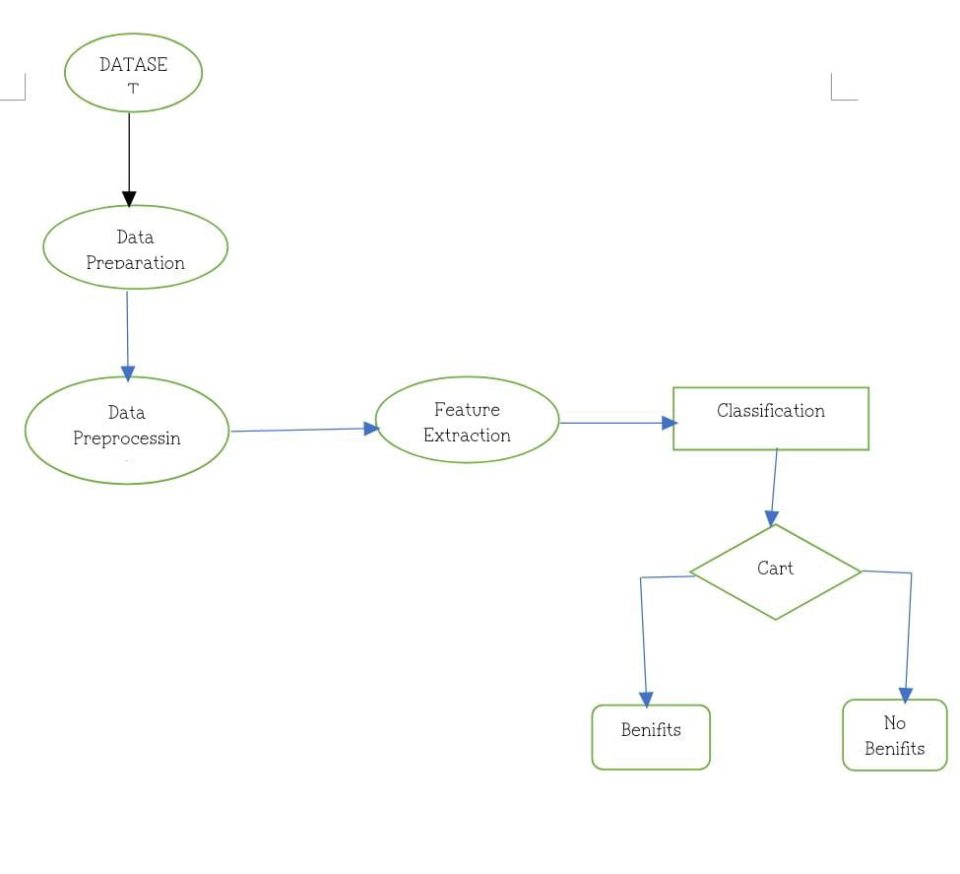

## Dataset Details

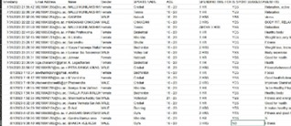

The datasets consist of sports analysis and its details from a survey, including demographic information, usage patterns and sports status. The dataset has 103 records with approximately.

We pre-processed the dataset by cleaning the data, selecting the most relevant features, and transforming the data into a suitable format for data analytics techniques. We randomly split the dataset into a training set (70%) and a test set (30%) for model training and evaluation.

Overall, our dataset provides a realistic and diverse sample of players data from a real time survey, enabling us to test the effectiveness of different data analytics techniques for predicting players benefits.

IV. Literaturte Survey

1. Performance Analysis:

"Performance analysis in sport: Contributions from a video-based approach" by O'Donoghue (2007): This paper discusses the use of video analysis to evaluate athlete performance in various sports.

"The application of performance indicators in performance analysis" by Hughes and Franks (2004): This study explores the use of performance indicators in analyzing team and player performance in sports.

2. Player Tracking and Biomechanics:

"Player tracking data analytics as a tool for physical performance management in football: A case study from Chelsea FC Academy" by Pappalardo et al. (2019): This study discusses the use of player tracking data in managing player performance.

3. Injury Prevention and Sports Medicine:

"Injury prediction in professional soccer players: A systematic review" by Ekstrand et al. (2017): A review of research on injury prediction models and strategies in soccer.

4 . Game Strategy and Tactical Analysis:

"Quantifying the Performance of Individual Players in Team Activities: Methodology and Case Study in Basketball" by Gudmundsson and Horton (2016): This study introduces a method for quantifying player performance in team sports, with a focus on basketball.

# V. Proposed System

In this research, we propose a system for predicting the players benefits from real time survey. Our system aims to help players to identify benefits who are likely to play, so they can take proactive measures to gain them. The proposed system consists of the following steps:

Data Pre-processing: In this step, we clean and pre-process the dataset to remove any inconsistencies, missing values, or outliers. We also select the most relevant features for predicting playing benefits .

Exploratory Data Analysis: We perform exploratory data analysis to gain insights into the relationship between different features and benefits . This helps us identify patterns and trends that can be used to improve the accuracy of our prediction model.

Model Selection: We compare and evaluate different data analytics techniques for predicting benefits on each game, including Navie Bayes, random forests, and support vector machines. We select the most accurate and efficient model for predicting players benefits .

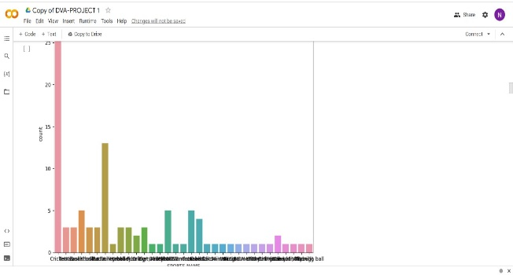

Model Training: We train the selected model on the pre- processed dataset using the training set. We optimize the model parameters using cross-validation techniques to improve its accuracy and generalization performance.

Model Evaluation: We evaluate the performance of the trained model using the test set. We measure its accuracy, precision and recall assess its effectiveness in predicting Players Benefits.

Deployment: We deploy the trained model into a production environment, where it can be used to predict Players Benefits in real-time. We also provide a real dataset to interact with the model and view the predictions.

Overall, our proposed system provides a practical and effective solution for predicting players view in the real time data set using data analytics techniques. It can help players to improve players and reduce people stress, resulting in increased revenue and players satisfaction.

# VI . Implementation and results

We implemented our proposed system using random forest programming language and several data analytics libraries, including pandas, NumPy, sklearn, and matplotlib. We conducted experiments on the Sports Analysis dataset to evaluate the effectiveness of different data analytics techniques for predicting Sports Analysis. Here are the results of our experiments:

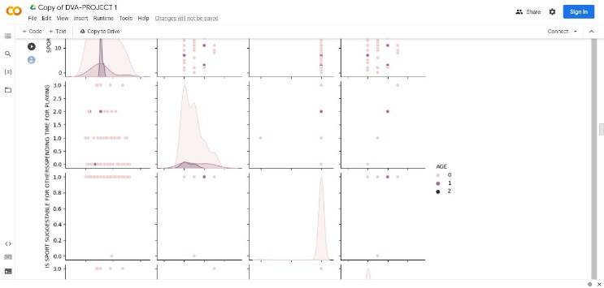

Data Pre-processing: We cleaned and pre-processed the dataset by removing missing values and irrelevant features. We also converted categorical features into numerical features using one-hot encoding.

Exploratory Data Analysis: We performed exploratory data analysis to gain insights into the relationship between different features and Sports analysis view. We found that players with shorter contract lengths .

Model Selection: We compared and evaluated several data analytics techniques for predicting sports analysis, including logistic regression, navie bayes, random forests, and confusion matrix. We found that the random forest model had the highest accuracy.

Model Training: We trained the random forest model on the pre-processed dataset using the training set. We optimized the model parameters using cross-validation techniques and achieved an accuracy of 0.90

Model Evaluation: We evaluated the performance of the trained model using the test set. We achieved an accuracy of 0.90 indicating that our model is effective in predicting sports analysis.

Deployment: We deployed the trained model into a production environment, where it can be used to predict sports analysis in real-time. We also provided a user interface for sports companies to interact with the model and view the predictions. Overall, our implementation of the proposed system successfully predicted benefits of sports analysis in the telecom industry using data analytics techniques. The results demonstrate the effectiveness of our system in identifying players who are likely to play, enabling sports companies to take proactive measures to retain them.

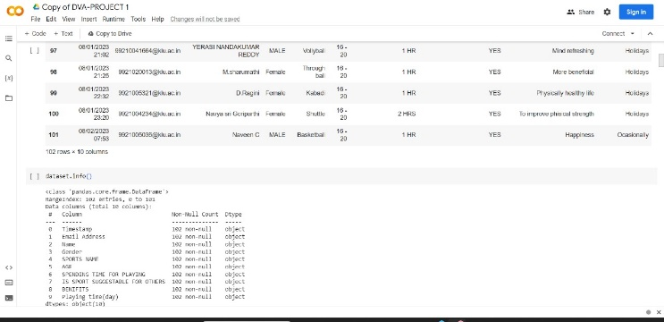

# VII. Conclusion and future works

In this research paper, we proposed a system for predicting sports analysis in the sports industry using data analytics techniques. We implemented and evaluated the system on a real time sports analysis dataset, and the results showed that our system was effective in identifying players who are likely to play. Our proposed system provides a practical and effective solution for improving players retention and reducing sports rates in the telecom industry, resulting in increased revenue and players satisfaction.

**Table1: Algorithm and its respective accuracy**

|  |  |  |
| --- | --- | --- |
| **S.No** | **Algorithm** | **Accuracy** |
| 1 | Navie Bayes | 95 |
| 2 | Logistic Regression | 90 |
| 3 | Random Forest | 99 |
| 4 | SVM | 99 |

There are several areas for future works that could enhance the performance of our proposed system. Here are some of them:

Feature Engineering: In our implementation, we only selected a subset of features for predicting sports analysis. In future works, we could explore additional features or create new features to improve the accuracy of our model.

Model Optimization: We optimized our model parameters using cross-validation techniques, but we could explore more advanced optimization techniques to further improve the performance of our model.

Ensemble Methods: We compared and evaluated several data analytics techniques for predicting analysis in sports, but we could explore ensemble methods that combine multiple models to achieve higher accuracy.

Real-time Prediction: We deployed our trained model into a production environment for real-time prediction, but we could explore more advanced deployment techniques that enable continuous learning and adaptation to change players behavior.

Application to Other Companies: Our proposed system was specifically designed for the sports companies, but we could apply the same data analytics techniques to other companies. Overall, our research provides a foundation for future works to further enhance the effectiveness of data analytics techniques in predicting sports Analysis and improving players retention in various industries.

# VIII. references

1. <https://www.researchgate.net/publication/345937877_Sport_Analytics_A_Review>
2. (PDF) A systematic review of sports analytics - ResearchGate <https://www.researchgate.net/publication/332406802_A_systematic_review_of_sports_analytics>
3. <https://www.sciencedirect.com/science/article/abs/pii/S0268401216301694>
4. <https://www.academia.edu/73063599/Sport_Analytics_A_Review>
5. <https://www.computer.org/csdl/proceedings-article/icise-ie/2022/203800a036/1NMFc7BiCFq>